ICT 2022 MENTORSHIP NOTES
NOTES BY @TANJATRADES
EPISODE 2
https://www.youtube.com/watch?v=tmeCWULSTHc
• Don’t expect that you will be perfect/ green every single day
• Otherwise when you get a loser you start revenge trading to correct it -> cycle of losing trades
• Look for short term lows, sell stops = liquidity
• Algorithms are looking to draw the market to those stops = where the liquidity is • There’s either liquidity or imbalances.
o Above old highs are buy stops
o Below previous lows are sell stops
• Anytime a significant price move lower is expected, always anticipate some measure of a stop hunt on buy stops or short term high being taken out
and vice versa:
• Anytime a significant price move higher is expected, always anticipate a stop hunt on sell stops or short term low taken out before you see a very pronounced move higher. Go through your charts and notice it occurs almost on a daily basis.
• During a consolidation phase, look at one hour chart and mark your support/resistance
• Look for stop loss hunting
• Once that occurs, you want to switch to lower time frame – 2 min and look for imbalances
• the 1, 2, 3 mins much better than 5 min because it offers the best for finding imbalances in indices. Algos work on small time frames.
• Use fib levels and the 50% mark to understand whether you are in ‘premium market’ aka expensive market- above the 50% level, or at a discount market below 50%. You use this to understand where you are in that range currently if you are going long or short and understand where the algorithms may want to take the market.
• 8:30am to 11am EST is a sweet spot where he focuses on.
• Summary:
• You’re looking for a run on liquidity. Buy-stops or sell-stops being run • Bearish- look for buy stops to be ran, then a break in market structure, aka a short term low being broken. You enter short in the FVG and your profit target is the most recent low nearby. And vice-versa if you are bullish.
• Reminder: there’s always going to be reasons why you didn’t do something right, didn’t hold long enough-- don’t beat yourself up over that.
EPISODE 3
INTERNAL RANGE LIQUIDITY & MARKET STRUCTURE
https://youtu.be/nQfHZ2DEJ8c
• Internal Range Liquidity- looking for short-term lows or short-term highs inside a price leg that we’re retracing back into
o Ex: Short term higher low with stops below it or an imbalance in that same range of price action
• How do you know it’s a market structure shift?:
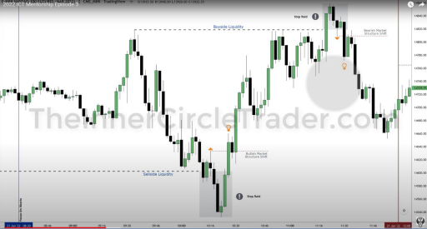• See minute 12:42 of video for more review.
• Fair Value Gap, aka FVG- (bullish example, such as above) look at the candles before and after the reversal candle that takes out the previous high. When the candle’s high before the reversal does not meet the low of the candle after--- it creates a gap. Important: only use at major levels, when a swing low/swing high is taken out… etc.
• When there are two fair value gaps, it might dip back into the deeper one as well. You let it trade into the deeper one and wait for it to retrace back to the shallow one and enter when its in there. More on this in minute 42:00 (live trade example)
• Order blocks (minute 14:38):
• Order block – A change in the state of delivery. A series of candles into buyside or sell-side liquidity.
• Place your entry limit order as the opening price of the order block + 3ticks for spread
• Note: every down closed candle is not a bullish order block, and up closed is not a bearish order block.
• Minute 23:40 for more
• Key times to trade:
• Mark the key highs and key lows for:
• 2am-5am ET - London session
• 7am-10am – New York session
• 7PM-9PM. Asia session
• AND any intraday high/low right before equities open at 9:30.
• Note what the highs and lows are from that session because the market will probably sweep above/below and create break of structure situations.
• Noon New York time is typically very problematic for set-ups… wait until 1:30 pm if you’re going to trade in the afternoon
• Typically an afternoon set up occurs between 2-3pm EST… but that’s out of the scope of this ICT mentorship
• Focus on the time frames in the bulleted list.
• Best time to trade this method is between 8:30-11am EST
• Reminder: you MUST have a strong mindset!!!!!
• Look for low hanging fruit, aim for the easiest target to get to- aka the next spot where previous stops are waiting.
• Don’t try to be perfect.
• Watch the chart, not your P/L.
• When you put in a trade with a plan, let the market do its thing. Don’t try to overthink every little fluctuation. Every little movement in price action should not sway you.
• You’ll need to grow into this method. The secret is to back-test!
EPISODE 4
https://youtu.be/L-ReMHiavPM
• 8:30am EST “starts the hunt”, look for old highs or old lows to be overtaken, then look for break of market structure.
• When you journal, note how long it took for:
o From market structure shift into the FVG
o From entry to the target
o How much drawdown would you have weathered
• Similarities occur: you need to train your eye to see it. Bottom line is you need experience.
• Reminder: start on the 15 min or 5 min to see stop hunting happen and then switch to 2 minute for the reversal/ FVG set up
EPISODE 5
https://youtu.be/N29ZJ-o31xs
• Noon to 1pm = no trade time period, do not trade. Not a clean time of day for price action
• What warrants a stop hunt?
o Start on the 15 min trimeframe. Look at prior to 8:30am high and low. (what the most significant/ obvious swing high/ swing low- draw horizontal lines there)
o Now, change into the 5 min chart
• 3 drives pattern- pressing up into liquidity- establishing short position 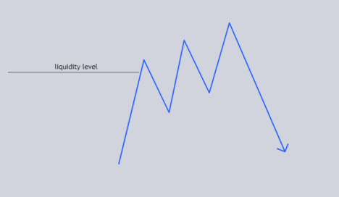• Displacement- look for the energetic /pronounced move in the oppose direction
• The day is designed to have a morning move, a lunch hour which you don’t want to be trading, and an afternoon move
• The daily candle – do you expect it to trade higher or lower.
• Monitor what the morning session does and what the afternoon session does o Then study what the daily chart was showing, days before when it had similar price action. It allows you to help find these big moves
• IF YOURE BULLISH: after 1:30pm, look for swing lows. Look for the first one. Look for the stop hunt. Look to go long after the stop hunt. Don’t try to trade for small “mickey mouse” moves
o Look for displacement higher and look for FVG and buy that. • Theres a macro algorithm that starts running at 1:30pm ET in equities • When news comes out, price action will start to be noisy, you can sit out during that time.
• Don’t try to micro scalp.
• If you catch a good trade in the morning, switch to demo in the afternoon, especially if you’re new, don’t give that money back.
EPISODE 6
https://youtu.be/Bkt8B3kLATQ
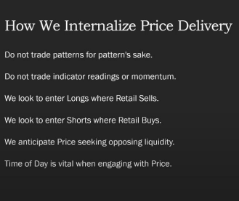
• That trend is not your friend when its at the end and its reversing… there’s always an exception to a rule
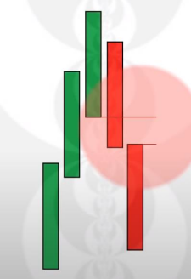
• Bearish ICT FVG:
o Based on 3 candle formation
o First candle – run over old high. Next
candle is extended low that goes
below, third candle is continuation
candle. Third candles high cannot
trade back to the first candle’s low
aka it must create a gap.
o Don’t look for random FVGs – must
run above a single high or multiple
highs (such as a double top)
o You put your stop above candle 1 or
candle 2
▪ That stop may feel like a lot of
range. You want a lot of range
when you’re starting out
o During Bearish Market structure shift – must rally above old highs, then quickly shift lower – quick displacement. We want it to be significant.
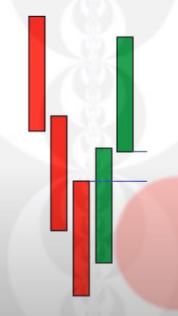
• Bullish ICT FVG:
o 3 candle formation
o Markets Runs below old low or
multiple lows for sell side liquidity then
quickly shifts higher
o It trades higher and takes out short
term high
• Always mark 8:30EST (Why? News usually
comes out that that time) and look to the left
– first swing high to the left- mark horizontal
line there)
• Look to take profit at previous FVGs and
also at sell stops/ buy stops.
• Better to take part of your position off and
hold onto your same stops.. otherwise if you
trail you will get stopped out early
• Close partial of your position inside internal
range liquidity (at previous FVG or at 50% fib
level), then close entire position at external
range liquidity (below intraday lows)
EPISODE 7
DAILY BIAS AND CONSOLIDATION HURDLES
https://youtu.be/G8-z91acgG4
• You should be risking less than 1% when you’re just starting especially if you don’t have a clear bias/ don’t know what you’re doing. ICT risks 3.5% o No reason to put higher levels of risk behind a move-- it will create toxic thinking and bad habits, and you’ll be afraid to execute based on the results you’re getting
o You want to be indifferent to the results by using demo account or by using small sizes
o You need to get over the idea of being right every time, and get rid of the idea of perfection (entry, exits, perfect sizing…)
o Embrace imperfection. Let go of the idea of being right every time. • Bias = looking at a daily chart and thinking about where you think that next day will go. However you will not be right every day. Days will go against you (up candle in a down trend/ vice versa)
• You will rarely catch the top and bottom perfectly…. No one trades perfectly. EMBRACE THE GRAY AREA in the market.
• Even if you have bearish bias, you can take long entry but do so with smaller size
• Once consolidation happens on daily chart, makes it hard to form bias o Look at smaller time frames and look for liquidity pools.
o Be a lot more nimble, take your money and run, don’t try to overstay your welcome
• Watches and uses $ES to gage entries for $NQ because they typically move in tandem
• If you are in a long, target old highs/ buyside liquidity/ buy stops. • Watches E-mini DOW as well ($YM), looks for divergences to CONFIRM bias (an idea you already established). Example: you have bull bias and $ES and $NQ made lower lows but $YM did not. You start looking for longs because sell side liquidity was taken out.
o By itself – this doesn’t mean anything… he blew accounts just looking for divergences… need to have a narrative as to why this would form.
• Macro = something inside an algorithm that prevents the delivery of price. Such as above when DOW did not make lower lows
• Algorithms run on time and price.
• Sometimes this method will end in a loss. That’s what your stop at the opposite even of the FVG is for… don’t think that you will be right every time. Don’t let that deter you from continuing the strategy.
• 9:30 opening is typically very sloppy/volatile
o Traders on the floor in the 90s sometimes wouldn’t have a feel for what’s going to happen… they would buy or sell 1 contract to get a feel for it. Especially in consolidation movements
o Why? Because you’ll have a greater feel for what the market is doing when you have some skin in the game.
o Watches how price delivers against that order – moving lethargically or quickly in the favor of it or running in the other direction. Makes you more attentive to reading price
• We are trading to make money, not to be perfect, not to impress others
EPISODE 8
APPLYING INSITUTIONAL ORDER FLOW TO FOREX MARKETS https://youtu.be/7rbV8aWkcqY
o In this short video he applies ICT to Forex.
o Mentions looking for FVG setup between 7-10am ET for the New York session or 2-5am ET for the london session. These are the 2 times he wants us hunting for setups.
EPISODE 9
POWER OF 3 & NEW YORK PREMARKET SESSION OPPORTUNITIES https://youtu.be/iZLXnNiZm_s
• Power of 3: accumulation, manipulation, and distribution
• If he’s bullish, he’s expecting the opening price to be near the low of the session, make a lower low, and then rallies, creates a high, and closes near high of day • Anticipate the market making a ‘false move’ aka fake runs
• You want to get your entry during those stop runs to get ideal entries. o Need your confirmations: did it take out short term low, is it inside a FVG, did you get an order block earlier?
• A bullish order block: consecutive down closed candles right before a price surge that has an imbalance, aka a displacement.
• Large overnight price run up (from 2-5am)- avoid the opening range o Don’t chase, wait
o Typically after a large run, there’s consolidation after
o Don’t trade a lot, you’ll get chopped up, wait for an opportunity, or swing low to happen
o Avoid NY session, wait for the after lunch session (1pm).
▪ Anticipate the New York lunch lows or morning session lows to get taken out. And then a rally afterward
▪ search for imbalances and FVGs to enter the trade.
o Price is volatile, expect some imperfection for price delivery, which is why you don’t place stop at the direct bottom of the FVG, but the bottom of the candle before it.
o You’ll have to learn to trust setups and let stops do their jobs
▪ If you get stopped out, that’s just one losing trade it’s not your
whole career
EPISODE 10
IMPLEMENTING ECONOMIC CALENDAR EVENTS WITH THE OPEN https://youtu.be/S9ORTYmXwdE
• You can find the economic calendar at https://www.forexfactory.com/calendar • Yellow =low impact, orange = medium impact, red = high impact news driver • Daily Bias:
Power of 3 aspect:
o The open on a day that is bearish is an accumulation of shorts
o The open to the high- subtract that range from opening price and that’s your opening range, which is where your FVGs and stop raids will happen ▪ Gives an area to bracket out how much leeway to give the market when it starts to break below opening price and still take favorable entry. Of course the ideal scenario is to short it from near the top
but that doesn’t mean the short is gone and other opportunities
come in near opening price - close proximity entries. If it leaves that area don’t chase it. Have discipline
• Many times the low of day on a large down day is formed near 3:30pm which is where distribution occurs
• If we are trading near bearish FVG on daily and there’s a bearish shift in market structure - gives you bias it will be a big down close day • When a green candle is going into bearish FVG it’s scary to short it—- you need to be able to study to get used to it
• He really likes 15 minute time frame for finding day trading setups, even scalping and swinging
• 15 min timeframe gives u the full picture of what price wants to do • Price was pumping the futures market before the news came out at 8:30am ET o that tells you that they were pumping price before the news was going to bring it lower as they established their shorts higher
• Energetic candles is how you know you have a shift in market structure • Start going to smaller time frames little by little until you find FVG formed. o If you don’t have it on the 1 min chart then you don’t have a trade • ICT bearish breaker - where you can put stop (short term top)
o More about breakers in his YouTube channel
• The measure of risk needs to be appreciated and respected
• Understand that may not get this right away and don’t be discouraged -- you’re new
• If the bias is bearish would you look for entry on bullish FVG? No. Write down your bias each day in the morning.
EPISODE 11
Examples of ICT concepts in recent price action
https://youtu.be/Sqw2bww93Zo
• If you are looking at the entire daily range, use the opening price at midnight • If you’re looking at morning session, use the 8:30am opening price o Lower highs give confirmation to bearish market structure
o Note your swing highs
• After a big move, you don’t want to trade in the morning session. Just don’t do it. Switch to a demo account to appease that desire – scratches an itch • After a nice winning day, he’s not in a hurry to go back in.
o Psychologically, after a big win you tend to want to go back in and get that dopamine hit again.
o You end up thinking its not enough, wanting to do more.
o Know when enough is enough
o If you made real money in a live account, you don’t want to rush to get back in there
o You don’t want to push your edge. If you keep pushing your edge you are going to dull it. You sharpen it by knowing when to get in and get out.
*EPISODE 12*
MARKET STRUCTURE FOR PRECISION TECHNICIANS (ADVANCED PRICE ACTION THEORY)
https://youtu.be/8GkQfdAXZP0
• He does not try to pick tops and bottoms.
• When we look at price we do not simply look at higher highs/higher lows • We look for whether it is likely to go up to take out buy stop liquidity or to balance any imbalances or vice versa (go down to take out sell stop liquidity or to rebalance)
• The daily range will not always submit to your bias, sometimes you will have consolidation
• All minor lower time frame swings will be subordinate to daily candle structure o Long term high should not be broken if you are short bias
o Internalize rebalances as intermediate term highs (ITH) / intermediate lows (ITL)
▪ If you have a bearish bias you must anticipate those intermediate highs as failures (bearish order blocks)
o ITH – has lower short term high (STH) to the left and the right of it. OR it trades back up to fully rebalance an imbalance
▪ If it is not higher, that is telling you that the market is very weak. ▪ You can go hunting for FVGs within the STH to the right of the ITH, see below (minute 38):
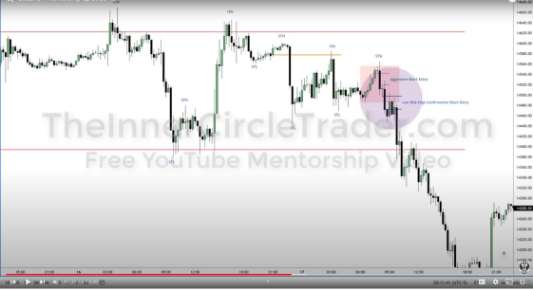
▪ If the STH to the right of the ITH is not lower, then your idea is
probably flawed, do not force it.
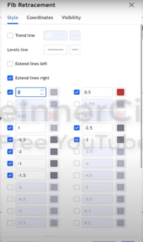
• Keep your perspective limited to a 5-day time
horizon, don’t try to predict more than a week in
advance
• If we have a break below an ITL, then we have a
significant break in market structure. Now you
can take the LTH and LTL and take the range
and predict how big the consequent move to the
downside will be.
o Or take the LTL and the ITH and draw
your fib levels from that.
▪ Why? Because the ITH is where
the retracement begins and what
starts the move lower.
▪ His fib settings --------------→
• Bearish order block: Consecutive up closed candles before the move lower. Not just the last candle before it.
• You must anticipate some imperfection in price delivery, don’t freak out. • When you see an imbalance get rebalanced, that high that forms during that rebalance should not be violated if you are bearish.
• Institutional order flow (bearish) – the tops of up-closed candles do not get broken into on bounces – shows institutional selling. Shows it is heavy • While the market is moving in your favor, continue to trust that move and hold onto your trade.
• If you’re bearish, up-closed candles should keep price below it • If you’re bullish and price is moving higher, down-closed candles should support price, will act as support structure.
o Only permissible that they break is if it is a STL and it is taking out some sell-stops to re-accumulate and go higher
• If your ITH is broken to the upside and you’re bearish, your idea was wrong, move to the sidelines. Don’t force it.
• In price swings that are bullish, down-closed candles are your support. In price swings that are bearish, up-closed candles are your resistance
• If you are trading against what the daily chart is likely to be doing… you are asking for failure. Doesn’t mean you can’t go long/ find long setups on a down day, but why would you want to? Don’t try to swim against the current
• If you can very easily communicate a bullish stance and really hard stretch to sell it for a bearish stance, that’s high probability.
o If you think it can go either way and you enter a trade anyway, you will regret it later. Easy to blow accounts doing this.
EPISODE 13
MARKET STRUCTURE FOR PRECISION TECHNICIANS (ADVANCED PRICE ACTION THEORY)- IN ACTION
https://youtu.be/tpPtItWqmlg
▪ Providing an example
▪ If you’re feeling butterflies/anxiety then you are not ready – you must desensitize yourself. If you lose you should be indifferent.
▪ He saw that /NQ was lagging behind /ES
▪ If the move has been bullish, downclosed candles should not be violated. They are going to act as support. Look at them as bullish order blocks and if
consequent candles wick into their bodies, that provides a possible entry. Take the opening price of that candle and extend it out in time to see potential entries. 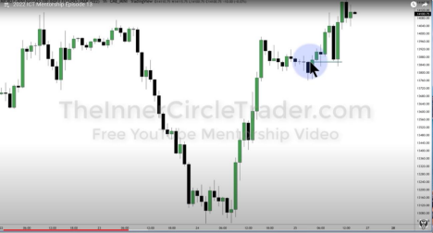Example at minute 13:49
▪ If move has been bearish, up-closed candles should not be breached or broken through. They will act as resistance.
o Overwhelming uncertainty eats at you even when you are in profit and makes you panic-sell/close out early. Remember that those candles can be filling imbalances so that smart money can accumulate more of their position.
o You must submit to your ideas and watch them come to fruition (takes months of experience)
o If you see a longer term price swing set up (on the hourly for example) you should try to hold it out for the move.
▪ ITL – has higher low to the left and to the right of it. = bullish market structure. o Zoom in on smaller time frames:
o Is the down-closed candle followed by an imbalance? If yes, that is a high probability bullish order block and it is likely to go higher.
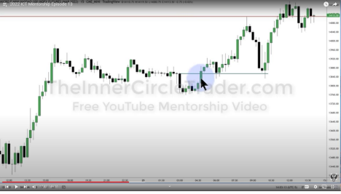Example at minute 17:43
▪ Remember that often the initial move when market opens at 9:30am is a “judas swing” aka a fake out. So if you are bullish on the day there may be an initial dip. ▪ Entry – you want a discount market entry (below 50%), you also want hunt for an FVG within that order block bounce on the smaller time frame
▪ Exit – where the liquidity is – prior buy stops
▪ Once it fills an FVG, an ITL is created and should not be taken out. Once it starts rallying it shouldn’t come back below the ITL.
o So, for trailing stop losses, you must set it below the previous down-closed candle/ bullish order block’s low. If you don’t you may get stopped out
early with small gain and you will be scared to get back in.
▪ He “pyramids” his position. Ex: buys 3 contracts at initial entry, if another buying opportunity presents itself (in a higher priced FVG) before profit target, he buys 2 more, then again one more.
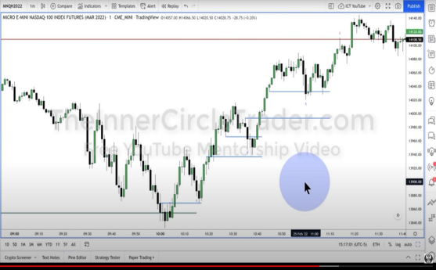
Example: he bought at the blue arrows and sold at the red arrow. (bought
3, then 2, then 1 contract)
• If you miss a trade today, there will be another one tomorrow. Do not overtrade and lose control, that is how you blow accounts.
• Don’t expect to be that precise at first.
• If you don’t aim for a target, you will hit nothing 100% of the time
• Have daily goals/ target. Shoot for low hanging fruit.
EPISODE 14
https://youtu.be/NUdu1n-ML98
• This episode was a 4 minute live action trading rundown
EPISODE 15
https://youtu.be/tGxuitjtO88
• Another live action trading example, this time near open
• Bottom of bullish FVG was taken out which can happen with morning volatility, wait for it to re-enter FVG for your entry if you are bullish
• FOMC day you can trade in the morning but you gotta be done early
EPISODE 16
FINDING MULTIPLE SETUPS
https://youtu.be/EpGQnhjXBq8
• If on the daily, a swing high takes out a previous high and then the next day’s high is lower, then the day after that he is looking to go short. See image below 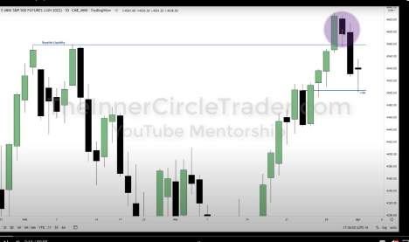
• If you’re trading index futures, the opening price is midnight, and also the opening price of the 8:30am EST candle.
o If you’re bearish ideally you want to see the market running above the opening price as manipulation
• Always extend the opening of order block candles as the level you’re looking at. • He uses fib retracements on the bodies of the candles of the swing high and low, not including the wicks. (he calls the wicks and tails distractions)
• Best to combine multiple ideas for confirmation - daily likely to go lower, presence of bullish daily order block, multiple equal lows = liquidity below, and fib level
• Mark out the opening price of the candle at midnight
• He doesn’t take no more than 2 trades in the morning and 2 trades in the afternoon
o Opening typically proves 2-3 setups. Right at open is tricky and most volatile, can get caught up on the wrong side. He prefers that we first look at the initial move to qualify what we are expecting
• 15 min time frame gives the framework
• He doesn’t take entries from 12-1pm ET but you can take profit during that time if you are already in a trade.
• Never be upset that you missed a trade. They’re like mass transit buses and come around all the time.
• Fridays have the possibility of retracing back into weekly retracement o Example: after bearish target hit: look for short covering and mark out where the buyside liquidity is
• Algos reach for liquidity (sell stops/buy stops) or to fill imbalances. (oversimplification of the concept)
• He goes over “mitigation blocks” on his youtube channel
• Main point of this video is if you miss one imbalance/FVG setup, look for the next one if your price target hasn’t been hit yet. You may find another imbalance/ FVG entry.
• If you have 2 FVGs, anticipate it going into the deeper one, but use the shallower one as your entry.
• He emphasizes that you must be back-testing
• Think about “where’s the money, who is the easiest prey right now”- that’s where the market will run for.
EPISODE 17
FOREX EXAMPLE
https://youtu.be/5WIqHJDQ_p4
• Draw out your levels on your charts to train your eyes to see it (ex: relative equal highs)
• Note your swing highs and ITHs on your charts
• Remember that if you are bearish the ITH should not be violated. • If you’re bearish and the opening price at 8:30 ET is lower than the one at midnight, you use the lower one. You want to set the minimum threshold for a judas swing/market protraction to the upside when you’re bearish. If you’re bullish, you’re looking for a judas swing move below the opening at 8:30ET to go long after it moves below it.
• You want to “fluff up” your exit aka pad up your limit sell by a few ticks before the exact level.
o Be more forgiving and incorporate the spread (esp on forex)
• When he trades futures on indices, he focuses on 8:30-11am ET o He’s fine with entering trades at 11:45am
EPISODE 18
https://youtu.be/eai0nHhAC8w
• Always start your bias analysis on the daily chart
• Everything he says in this video unless otherwise stated is specific to forex • It’s important to know what you’re looking for ahead of time, so you’re not changing gears back and forth intraday, chasing impulsive price swings
• Stick to your bias and only wait for those types of setups (long only or short only) unless you are proven absolutely that you are wrong.
• There is no way for a trader to never lose, there’s no strategy that never loses • You don’t need to be perfect. Imperfection can double your account. • If he had a funded 100k trading account and he was starting out all over, he would use this model.
• There’s lots of liquidity around previous day’s highs and lows and high frequency trading algorithms attack those areas as well.
• He has his screen into 3 parts: daily, hourly, and 15 min timeframe o He is always referring to the 15 min time frame
• After a swing high/ buyside liquidity is hit, is there a displacement to the downside? Does it create imbalance? Is there a FVG? -> bearish setup • Whenever there’s a large imbalance he puts his stop at the top of that imbalance, not the candle before it.
• What makes an order block valid? It has to have an imbalance after it. • You can hold your position through lunchtime but if he hasn’t entered by 11 he waits until the afternoon.
• He doesn’t suggest trading gold futures. Gold is an event driven market and is highly manipulated, lots of stop hunts etc., should not be aggressively trading it short term
• He emphasizes back-testing and annotating, journaling your entries • If it isn’t obvious to you what you’re looking for in the beginning, that is normal • Keep going into charts and logging and observing
EPISODE 19
https://youtu.be/IEa1N0rTtbc
• You don’t need perfect entries, you can be very average on your entries. You just need sound money management.
• A lot of money stays on sidelines during holidays such as the week of Passover • Your best bet is making money with the algos
• For bearish order blocks you can use the low and the opening price of the lowest up-closed candle
• Think of orderblocks as ‘bookmarks’ for algos. They want to come back to that spot later on… (when they fill imbalances/ FVGs – provide entries for us) • If you are going with a short term trend, against a long term trend on a higher time frame, he claims that you will blow your account as a new student • Things you need for ICT concepts to work:
o Responsibility
o Adherence to rules
o Give Yourself Time
• You have to learn how to read price action or else you will fail
• You must wait for it to come back to fill FVGs, have the patience, don’t chase large displacements
• It takes time for you to get your bias’s right, especially when you’re new • You don’t even know your favorite style yet!
• Every day, even when you’re wrong, they’re all learning experiences • If you can’t reasonably outline whether we are going higher or lower that day, you are gambling
• He does not promote lucky overloaded leveraging
• You don’t have to trade every day, but you can have your bias and your reasoning why it’ll go higher/lower that day
• No rushing, no gambling
• Lower your expectations of yourself-- don’t try to be an Olympic trader, all you need is consistency and money management.
• Purge and Revert
o When price action purges sell stops and then reverts back into the high of the last 3 daily candles
o He has a separate video on this
• Mean threshold = 50% price level in an orderblock, the easiest part is for it to draw into the low of the candle, then the 50% threshold would be the next level. o Pick the lowest hanging fruit and be happy when it hits that.
• If we have gone down to equilibrium or short term discount, it is likely it will go higher the next day
o If it doesn’t happen then try again the next day
• He goes over playing the NY open
o Mark out the midnight open price and the 8:30 Et opening price, look for judas swing + FVG + orderblock = great entry
• Do not paper trade with leverage, it’ll make it seem like a videogame and you’ll feel a “rush” of emotions
o Make it as boring as possible
• Focus on the points, not the money
• "Being consistently profitable is a lot better than clout on the internet" • None of these jokers on the internet should have any influence on you
EPISODE 20
https://youtu.be/Q6GFu8-Z4rY
• Forex example
• The market does not like to leave relative equal highs --- retail sees this as resistance---the market likes to run through them later
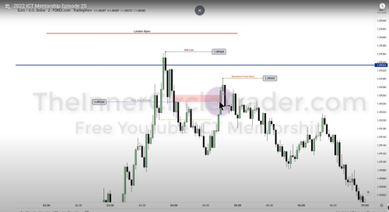Short Example at minute 13:44
EPISODE 21
https://youtu.be/kmVXVJE08eQ
• If dollar is going up then it’s a risk off scenario… generally every other market/asset will decline as money pours into the dollar and out of foreign currency and the stock market
• $ES retraced within the bearish order block before going lower, see below: (minute 8:28)
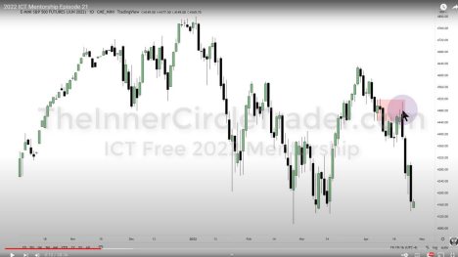
• We’re looking for a run below those relative equal lows on $ES
o Once we hit there, we can either violently accelerate to the downside or have a sharp retracement higher. He doesn’t care to know that, we are submitting to the idea that we are going to keep drawing down on the daily chart to go for the lows.
• Midnight is good for framing London time 2-5am. He doesn’t trade this session but he looks at what happened during it to see if his daily bias is working out so far (aka see if a judas swing happened followed by displacement in accordance with his bias)
• Sometimes you’re not going to get the large judas swing- he was expecting a larger one today and it didn’t materialize
• You’re going to miss moves and misinterpret things- that’s normal. That’s why you have a stop loss, and you also have to have a measure of flexibility- which will come in time.
• Midnight opening candle is what he maps out and what he looks for in his daily range power of 3 set up.
o Ideally if he’s bearish—he wants to see a rally above it
o If he’s bullish he wants to see it decline below the opening price • Today it never rallied above 8:30 ET opening price, it’s too heavy. He uses the same thought process as the midnight open--- looks for judas swing/suspect rally.
• We didn’t rally above opening price at midnight, or the opening price at 8:30 ET, and we’re bearish = we’re extremely bearish.
o Which means it won’t give any short term rallies, will just stay heavy. You can either get in, find small little pockets of imbalance, or you miss the move entirely.
o These types of moves are going to be very frustrating if you’re new— sometimes the markets are simply too heavy and they’re not going to rally for you.
• April 26th simply didn’t give his YouTube set up on the 5 min timeframe aka the Power of 3
o Reminder: Power of 3: Accumulation, Manipulation, Distribution • He stopped holding overnight years ago, he doesn’t trust the market. He only day trades
• Typically his trades are 90 mins- 2hours max
• Too much risk right now in the market place in all asset classes • At the 9:30ET opening, he is expecting initial volatility
o Today at 9:30 it starts running lower immediately, and didn’t give us a rally at all, just started accelerating the move from the 3am London session
• There was a short entry for /Es at 9:48 on the 3 minute chart – FVG + bearish OB 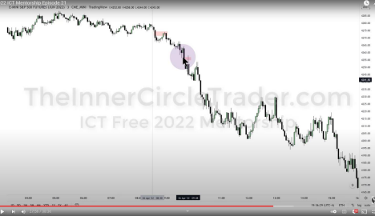
o It’s useful because you have more insight on what its doing- if its too heavy and unlikely to rally, no reason to go long, look for reasons to go short, and every time you get an imbalance and we are still above the relative equal lows on the daily chart- look to go short- as market is going to look to draw into that. Price is gravitating towards that area now. We just don’t know how long its going to take to get there.
o He doesn’t like how fast we’re getting there as its not creating many opportunities and it isn’t scalable with his current YouTube model.
o Sometimes the market does not give us what we want or expect and trading these markets is very difficult. Give yourself permission to be human! You’ll miss moves.
• Many times in his early days he blew accounts trying to buy “oversold” scenario
EPISODE 22
https://youtu.be/QKc_i90chVg
• Goes over price action of the market session on Friday 4/29/22 • Anytime the market trades above an old high, that is a short term premium because its going into liquidity. Anytime it trades into an old low, it’s a discount o Things can be at a premium and go higher and be at a discount and go lower
o That’s why you have to understand the narrative within market structure… aka why you think market is heading higher or lower
o Based on climate, economic calendar events, and volatility on that day • If we’re bearish and expecting lower prices and NQ is making a bigger buy stop run in the morning than ES & ES is really weak, this stop run gives you confirmation that we are heading lower
EPISODE 23
https://youtu.be/QKc_i90chVg
• Goes over FOMC price action
• Sweep = shallow run through liquidity and reverses
• Run = runs through liquidity and continues
• Shows how during FOMC price action filled previous imbalance before running through highs
EPISODE 24
HARDLINE PSYCHOLOGY DISCUSSION - RESPONSIBILITY & MODEL DIAGRAMS
https://youtu.be/nv0ey5UyOmY
• Trader psychology video
• Because FOMC has created the move he didn’t think non-form payroll would have a big effect
• Must incorporate the element of time – what time is it? 9:30 – likely to create a false move
• Do not impulsively get into a trade without a setup, this is how you blow up accounts
• Say to yourself: “I promise for as long as I do this, I will endure losses.” o Notice he says endures, not defeat. Every successful trader has losses that they manage.
• Where do setups form? (Bearish example, inverse for Bullish)
o Sweeps above old highs and displaces lower, creates FVG to short into o Or goes into previous bearish FVG and displaces lower, creates FVG to short into
o If this structure doesn’t happen, you don’t enter the trade. And you have to be okay missing big moves.
• You have control over the mental impact of your losses, you have to condition yourself that when setbacks happen, you say that you’ve been there before and you got through it, you can’t let it completely derail you.
EPISODE 25
https://youtu.be/CnTXwAuDi9Y
• Avoid toxic thoughts- don’t let them build
• Enjoy the process
• You don’t need to pick exact bottoms- he’s tried to do that before and lost more money that way than anything else.
EPISODE 26
EXAMPLE OF TAPE READING PRACTICE
https://youtu.be/k26euOG6zAk
• Example of trading against the daily bias, trading $ES
EPISODE 27
COUNTER TREND IDEAS
https://youtu.be/gLK4Qm6jte8
• Shows that if you are waiting to go long in the afternoon – after a consolidation move- wait until you’re at a discount to do so and in a previous FVG or break of structure with FVG after that.
• If you’re bullish – find the lunch consolidation lows- wait for the break of them to get in long.
• You need to put positive self talk in your back testing annotations to trick your brain.
o You’re building pseudo-memories and making yourself more confident in the future and building muscle memory.
EPISODE 28
https://youtu.be/j0Z2EbuJXGU
Short 2 min video showing execution
EPISODE 29
https://youtu.be/QkokVv0owSE
• He was long bias because of previous relative equal highs left untapped on NQ – looking for that draw on liquidity
• Market was ‘lethargic’ because tomorrow two major events – JPowell speaking so it will be a small range day, a quiet day.
• NQ made a lower low, while ES resisted going lower. Again the same divergence happened at 11am
• Best to enter position in a FVG within 50% or higher retracement within the displacement.
• Close proximity entry – if you miss your entry – you can get in near to it or at the next BOS and FVG as long as it is good R:R
• He chose long in ES because it was relative strength according to the divergences and he was long bias.
EPISODE 30
https://youtu.be/CL94EnGqB4Q
• Explains how today’s Powell speech price action was manipulated • Always look at relative equal highs and expect them to be ran.
EPISODE 33
https://youtu.be/8z6My18WZqA
• Went over FVGs after broken levels were the entries for shorting on Friday and there was also a long opportunity for the squeeze into close.
• When a mean threshold- aka 50% of a bearish order block is taken out on the daily- that bodes well to take out the next short term high (aka the top of the bearish imbalance)
EPISODE 37
https://youtu.be/HuZurY0ghDI
• Bias – when the market is moved from a low and creates a swing low, it’s easy to assume it might want to come back to the most recent short term high. • He does not advise people to try to speculate on non-farm pay roll days (NFP) o Don’t trade them – you’re here to read price action. Non-farm payroll price action can be very volatile, choppy. You don’t have the experience to weather it. You shouldn’t be gambling live money.
• You can get hurt very quickly in NFP and FOMC weeks
• He says if you made money on the first few days on the week, take a break for those days. Students can lose a lot of their precision on those days. It’s a disadvantage
• He urges his students to not take any trades on that Wednesday. It forges discipline and patience. You will be rewarded emotionally and psychologically • Emphasizes Power of 3- after the manipulation look at where the market is drawing to.
• When you are back testing and annotating – you are creating positive self-talk. Never put anything negative in it
• You have to be annotating and journaling to succeed.
EPISODE 38
https://youtu.be/36184dDAqtM
• He will go over how to change gears in a bias if it is applicable. • Multiple lows are taken and then market reversed- 4070 liquidity level left in place • He calls them fair value gaps because they are fair values of where to buy the contract if you are bullish / short it if you are bearish.
• He doesn’t believe that imbalances need to be filled fully.
• Narrative – the understanding of what price should do, why, and what things will it encounter to prove that the narrative you are assuming is in place is in fact underway.
• Price respected a daily fair value gap and ran higher, taking out a short term high – setting up the afternoon trend/ move higher.
• On the 15 min it pulled back into a 15min FVG – then he switched to a 5 min timeframe. On the 5 minute it doesn’t show as a 5 minute FVG – but if you shaded it from the 15min it would be highlighted.
• His YouTube model is mostly for the NY morning session
• If we are in an obvious uptrend then that’s an easy setup – but we are inside a range on the daily- you have to know what you are doing to play within the ranges; don’t try to be a hero holding for a further break out
• Morning divergence- $ES was stronger than NQ at 9:30 open, where $NQ made a lower low
• ICT teaches that if we are bullish, we want to be buying at or close to the opening price at midnight.
o Advanced strategy- if you know the market is likely to go down to go up you can buy during the manipulation
• When can you trade during lunchtime? – during a sell stop raid during a retracement during lunch (rather than a consolidation)
o When the market is trading fast/furiously
▪ Back in the day, on days when the market was fast, floor traders would often skip lunch and stay on the floor
• The market should not come back into a FVG a third time – it probably won’t hold up that time
• He waited for the market to rally first to show that the market was definitely bullish for the day, then he bought sell-stops during the retracement. • You need patience to get into a setup and once you get into the trade and let it pan out
EPISODE 39
https://youtu.be/yFpHbBnsK_c
• Narrative requires experience
• If you are trying to short you should be above or near the 8:30am open • Rules for afternoon session trade:
o Consider this: what is the daily range trying to do? Expand higher, lower, did it reverse during the morning session, and is going to have a counter trend move? Or is it going to consolidate because of a news event the
following day?
• 12-1pm is New York Lunch
o If we are bearish, the market will clear stops during lunch hour.
o A fast market can create a significant high/low during the lunch hour
• If you don’t have your narrative, you have an aimless speculation. Otherwise you won’t recognize a stop raid/bearish breaker
• People have different trading personalities – whether they are trying to get only a piece of the pie or whether they are trying to catch the whole daily range is part of their personality and thus will affect trading style.
• For example, his son has an attention span problem, so he focuses on only securing 5 points
• You need to squash FOMO through backtesting.
• Leans heavily on TIME element – time of day, week, month, seasonal influences. • If you are stopped out, it creates fear + anxiety + uncertainty. This is why TIME has to be considered first.
• Retail traders have trouble picking the right levels. If the framework is still valid but you didn’t have the right entry, try a smaller leverage next time.
• Think of price as the daily range has its limitations until manual intervention comes in
• Even if you are uncertain, keep showing up and you will eventually get it • He knew that price was reversing when the order block was overtaken because
he says there was reversal because sell side was taken 3 times without moving very much
• When you learn this skillset, it removes fear and anxiety of missing out
EPISODE 40
https://youtu.be/koN1ge8bewI
• Always take partials at first target, so if it reverses on you, you’re paid. • The Key to Daily Bias is experience. See more below:
• Only trade on days when there are high impact or medium impact calendar events. That is a low hanging fruit day.
• Moves that happen before the calendar event- that’s just a missed opportunity. Sometimes that happens. Let it go.
• The trader that trades every day and forces it- it will make you more prone to losing trades.
• Trading every day is problematic especially when you have a lack of self-control = destroyed accounts.
• Whenever there’s huge wicks taking out both buyside and sellside (typically during FOMC)- he ignores those wicks, its all manipulation
• If your directional bias is correct, London session created the high/low
EPISODE 41
https://youtu.be/2XhDi5GoNUI
• If you follow the rules and don’t trade during lunch hours, you are sometimes going to miss moves and that’s okay.
• Prefers to see a stop run in lunch hour
• Likes to wait until 1:30 for cleaner price action
• If price action meaningfully bounces from a FVG twice, should not come back to it and fill it completely a third time.
• When do you move your stop?
o He likes to take partials and keep initial stop
• Gold standard: FVG + OB and optimal trade entry after a short term MSS • RISK MANAGEMENT is covered in this video. You should use a calculator to calculate your position size according to risk.
• Drawdown must be managed. If you have a loss, reduce your risk in your next trade by taking smaller size. You are going to want to overleverage and revenge trade- that is a gambler’s mentality.
• Professional money managers do not allow themselves to touch their account when they are highly charged and emotional
• You don’t need to make up your loss back right away. Have a long-term view. The last few trades do not define you. One single trade is NOT a make it or break it. Your career is not going to be 10 trades and you made it. Longevity + controlled risk + impeccable risk management = consistent profitability.
• You will be in periods where it is very difficult. That is just part of being a trader. It just means you have to take a monetary pause and that is just a tax on success.

